|  |  |
| --- | --- |
| **Ex. No. 07** | **STRING, STRINGBUILDER AND REGULAR EXPRESSIONS** |
| **11.09.2023** |

**Aim**

To develop C# console application using String, StringBuilder and Regular Expressions to demonstrate various method of it.

**Description**

**String:**

System.String class allows a large number of operations on strings some of them were discussed below, They are immutable in nature.

* .Length: prints the number of characters in the string
* ToUpper(), ToLower(): converting the case to upper and lower respectively
* Split(): splits the string based on the object that is passed
* SubStr(): Gets the substring from the given string.
* Insert(): Inserts a string in the string where the index will be specified.

**StringBuilder:**

Dynamic object, instead of creating a new separate memory it just expands the memory and accommodates it.

Available properties and methods are as follows: .Length, Append(), AppendLine(), AppendFormat(), Insert() and Remove().

**RegularExpression:**

Defined under System.Text.RegularExpression, Patterns to match string. Some of the symbols and their meaning are as follow: ^: Beginning of a text, $: End of a text, .: Any single character except \n, *: zero or more times of preceding character, +: one or more times of preceding character and ?: zero or one time of preceding character.

**Source Code**

**1.**

using System;

using System.Text;

namespace Ex6{

internal class Section1{

static void Main(string[] args){

Console.Write("Enter Any string: ");

string str=Console.ReadLine();

while (true){

bool flag = true;

Console.Write("\n1. Length \n2. Insert Into String \n3. Remove From String \n4. Replace String \n5. To Upper \n6. To Lower \n7. Split String \n8. Copy String \n9. Contains To \n10. Join \n11. Sub String \n0. Exit \nEnter Your Choice: ");

int ch = Convert.ToInt32(Console.ReadLine());

switch (ch){

case 0: flag = false; break;

case 1: Console.WriteLine("\nLength of the String: " + str.Length); break;

case 2: Console.WriteLine("\nInserted String: " + str.Insert(0, "|INSERTED|")); break;

case 3: Console.WriteLine("\nRemoved String: " + str.Remove(str.Length / 2)); break;

case 4: Console.WriteLine("\nReplaced String: " + str.Replace(str[0], str[1])); break;

case 5: Console.WriteLine("\nUpper Case: " + str.ToUpper()); break;

case 6: Console.WriteLine("\nLower Case: " + str.ToLower()); break;

case 7: String[] li = str.Split(new char[] { 'a', 'e', 'i', 'o', 'u' }); Console.Write("\nSplited String: "); for (int i = 0; i < li.Length; i++){ Console.Write(li[i]+", "); } Console.WriteLine(); break;

case 8: var str1 = str.Clone(); Console.WriteLine("\nCopied String: " + str1); break;

case 9: Console.Write("String to Check: "); String s = Console.ReadLine(); Console.WriteLine("\nContained in: "+str.Contains(s)); break;

case 10: Console.WriteLine("\nJoined String: "+str+"|ALPHA STRING|"); break;

case 11: Console.WriteLine("\nSub String: "+str.Substring((str.Length%2)+1)); break;

default: Console.WriteLine("Please Enter a Valid Choice"); break; }

if (!flag) { break;}}

Console.ReadKey(); } } }

**2.**

using System;

using System.Text;

namespace Ex6 {

internal class Section2 {

static void Main(string[] args){

Console.Write("Enter Any String: ");

StringBuilder sb = new StringBuilder(Console.ReadLine());

Console.WriteLine("Results of the Opearations:");

int sbl=sb.Length;

Console.WriteLine("1. Length: "+sbl);

sb.Append("|APPENDED|");

Console.WriteLine("2. Append: " + sb);

sb.AppendLine();

Console.WriteLine("3. AppendLine: " + sb);

sb.AppendFormat("{0} Inserted", "|APPEND FORMAT|");

Console.WriteLine("4. AppendFormat: " + sb);

sb.Insert(0, sb+" ");

Console.WriteLine("5. Insert: " + sb);

sb.Remove(sbl,sb.Length-sbl);

Console.WriteLine("6. Remove: " + sb);

Console.ReadKey();}}}

**3.**

using System;

using System.Text;

using System.Text.RegularExpressions;

namespace Ex6{

internal class Section3 {

static void Main(string[] args) {

Console.Write("Enter Any String: ");

String str = Console.ReadLine();

Regex title_regex = new Regex("\\B[A-Z]+\\B");

Regex lower_regex = new Regex("\\B[a-z]+\\B");

Regex digits_regex = new Regex("[0-9]");

Regex email_regex = new Regex(@"^([a-zA-Z0-9_\-\.]+)@([a-zA-Z0-9_\-\.]+)\.([a-zA-Z]{2,5})$");

Console.Write("Is Title Case: ");

if (title_regex.IsMatch(str)) { Console.WriteLine(str); }else { Console.WriteLine(false); }

Console.Write("Is Lower Case: ");

if (lower_regex.IsMatch(str)) { Console.WriteLine(str); } else { Console.WriteLine(false); }

Console.Write("Has Digits: ");

if(digits_regex.IsMatch(str)) { Console.WriteLine(true); } else { Console.WriteLine(false); }

Console.Write("Email Validation: ");

if(email_regex.IsMatch(str)) { Console.WriteLine("Passed"); } else { Console.WriteLine("Failed"); }

Console.ReadKey(); } } }

**4.**

using System;

using System.Text;

namespace Ex6 {

internal class Section4 {

static void Main(string[] args){

Console.Write("Enter Any Line: ");

String str=Console.ReadLine();

int alphabets_count=0,vowels_count=0,consonents_count=0,digits_count=0,whitespace_count=0,special_count=0;

for(int i=0; i<str.Length; i++) {

char c=str[i];

if (char.IsDigit(c)) { digits_count++; }

else if (char.IsLetter(c)){ alphabets_count++; if ("aeiouAEIOU".Contains(c)) { vowels_count++; } else { consonents_count++; } }

else if(c==' '){ whitespace_count++; }

else{ special_count++; } }

Console.WriteLine("#. Alphabets: "+alphabets_count);

Console.WriteLine("#. Digits: " + digits_count);

Console.WriteLine("#. Consonents: " + consonents_count);

Console.WriteLine("#. Vowels: " + vowels_count);

Console.WriteLine("#. Whitespace: " + whitespace_count);

Console.WriteLine("#. Special Character: " + special_count);

Console.ReadKey(); } }}

**Output**

**1.**

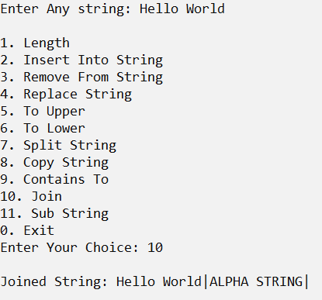

**2.**

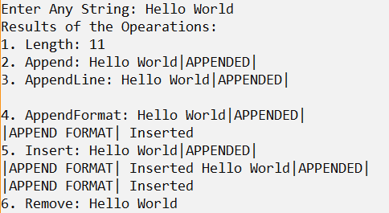

**3.**

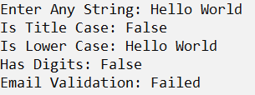

**4.**

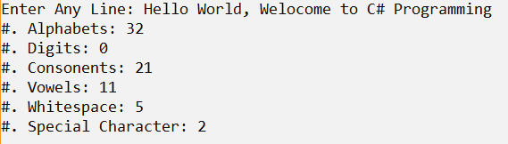

**Result**

The C# console application using String, StringBuilder and Regular Expressions to demonstrate various method of it has been executed successfully and the desired output is displayed on the screen.